**Excel Assignment – 9**

1. **What are the different margins options and do we adjust the margins of the excel worksheet?**

* Excel, you can adjust the margins of a worksheet before printing it. Margins define the space between the content and the edges of the printed page. To adjust the margin in Excel, you can go the page layout tab and click on the “Margine” button.

Different margin options available:

1. Normal: This is the default margin setting in Excel. It provides a balanced margin size for most printing needs.
2. Wide: Wide margins allocate more space around the content of the page, resulting in larger margins.
3. Narrow: Narrow margins reduce the space around the content of the page, resulting in smaller margins.
4. Custom Margins: This options allows you to specify your own custom margin sizes for the top,bottom,left and right margins.

By adjusting the margins, you can control how much space is left between the content and the edges of the printed page.

1. **Set a background for your table created.**

- 1.Select the table you want to set a background for. You can click and drag to select all the cells in the table.

2. On the Excel ribbon,go to the “Home” tab.

3. In the “Font” group,click on the fill colut .It is represented by a paint bucket icon.

4. A colour palette will appear. Choode the color you want for a background of the table by clicking on it.

5. The selected color will be applied as the background for the cells in the table.

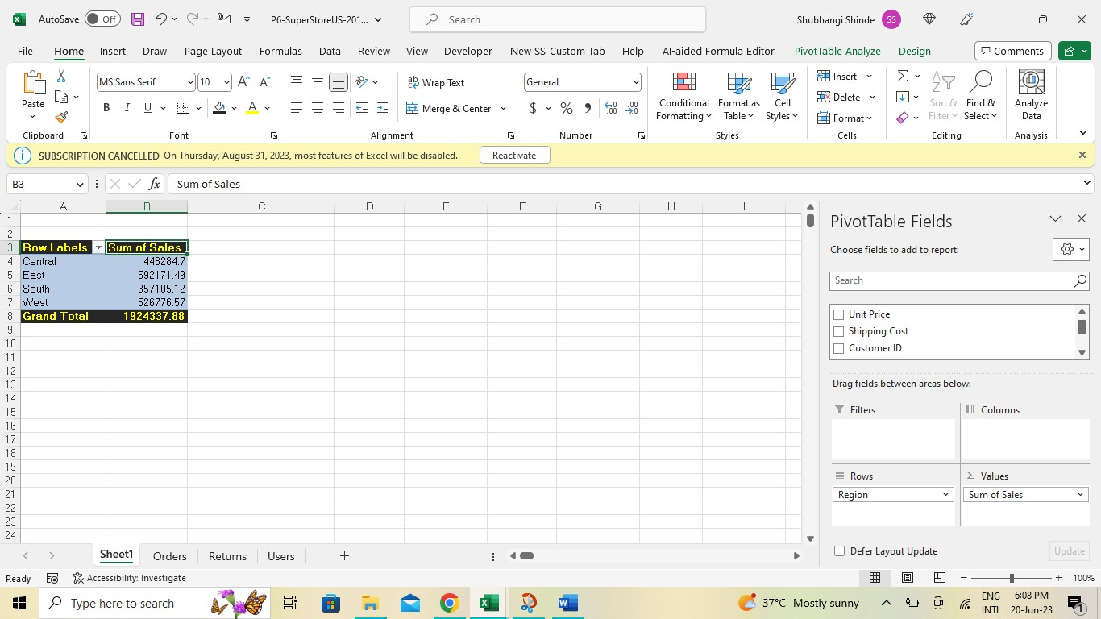

1. **What is freeze panes and why do we use freeze panes? Give examples.**

* Freeze Panes is a feature in Excel that allows you to keep certain rows or columns visible while scrolling through a large worksheet. When you freeze panes, the frozen rows and columns remain static, while the rest of the worksheet can be scrolled.

We use Freeze Panes for the following reasons:

1. Easy Navigation: When working with large datasets, freezing panes can help in keeping important headings or labels visible at all times.
2. Comparison and Analysis: Freezing panes is particularly useful when comparing data across different sections of a worksheet. By freezing specific rows or columns,you can keep them in view while scrolling horizontally or vertically,making it easier to analyze and compare data side by side.
3. Print preview: When preparing a worksheet for printing,freezing panes allow you to ensure that important information such as headers or title remain visible on each printing page,providing clarity and context to the printed document.

Example:

1. Select the cell below the row you want to freeze and to the right of the columns you want to freeze. In our example ,select cell C2.

2.Go to the “View”tab in the Excel ribbon.

3.In the Window group,click on the “Freeze Panes” button.

4.From the dropdown menu, select Freeze panes.

**4. What are the different features available within the Freeze Panes**

**command?**

- Freeze Panes is feature in Excel that allow you to keep certain rows or columns fixed on the screen while scrolling through a large worksheet. By freezing panes,you can ensure that specific data remains at all time,even when you navigate through the rest of the worksheet.

We use Freeze Panes for the following reasons:

1. Header and Title Visibilty: When working with large datasets or lengthy worksheets,freezing the top roe containg column headers or title can be beneficial. It keeps them in view as you scroll down,making it easier to understand the data and maintain context.
2. Column and Row comparison: Freeze Panes is helpful when you want to compare data across different sections of worksheet. By freezing specific columns or row,you can keep them static while scrolling horizontally or vertically,allowing for easier comparison and analysis.
3. Print Layout: Freezw Panes also plays a role in print layout. By freezing specific rows or columns,such as headers,page titles,or summary information.

Example:

Consider a sales report with multiple column and rows. To freeze the top row and the leftmost column.

1. Select the cell below the row and to the right of the column you want to freeze. For instance, select cell B2 to freeze the top row and the leftmost column.
2. Go to the “View” tab in the Excel
3. In the “Window”group click on the freeze panes button.
4. From the dropdown menu, select “Freeze Panes”.

Now, When you scroll through the worksheet,the frozen row and column will remain visible, enabling you to reference important information while exploring other data.

1. **Explain what the different sheet options present in excel are and what they do?**

* Here are some of the common sheet options in Excel and their funcations:

1. Rename Sheet: This option allows you to change the name of the current worksheet. Right-click on the sheet tab,select “Rename” and enter the desired nam.
2. Insert sheet: This option lets you insert a new worksheet within the workbook. You can either righr-click on a sheet tab and choose “Insert”
3. Delete Sheet: This option allow you to remove the selected worksheet from the workbook. Right-click on the sheet tab and select “Delete”.
4. More or copy sheet: This option enables you to move or make a copy of the current worksheet within the workbook.Right-click on the sheet tab,choose Move or copy select the destination and specify whether to create a copy or move the sheet.
5. Tab Color: This option allows you to assign a color to the sheet tab for better visual organization.
6. Tab order: This option enables you to change the order of the sheets within the workbook.
7. Protect sheet: This option allows you to protect the contents and structure of the worksheet. You can restrict editing, formatting and other chages by applying a password or specific permissions.